- Lending data from the Bank of England suggests households' demand for unsecured credit remains weak, but that housing activity is starting to strengthen. We think mortgage rates could drift lower in the near-term, supporting demand. But with market pricing already erring on the side of dovishness, the chances of a more meaningful fall in mortgage rates look low.
- In a speech this week, the prime minister continued to lay the groundwork for tax rises in the Budget on October 30. Talk of those with the broadest shoulders bearing the heaviest burden was consistent with reform of the capital gains tax regime and changes to pension reliefs playing key roles in the pursuit of extra tax revenues.
The week's only major data release – the Bank of England's Money and Credit data for July – suggested that the wait goes on for consumers' appetite for credit to strengthen but offered more promising news on the housing market.
Though net unsecured lending picked up to £1.2bn in July from £0.9bn in June, this was entirely due to a sharp fall in the volatile repayments component. Gross lending, which maps more closely to consumer spending, dropped back to its lowest level for three months, suggesting consumers remain cautious. We're optimistic that this will turn around and, alongside continued solid real income gains, underpin a pickup in consumer spending growth. Responses to the GfK survey for consumers' expectations about their financial situation and the climate for making major purchases have strengthened markedly in recent months. But so far, the credit data has remained stubbornly weak.
The picture around the housing market looks more positive. There's been a close relationship between quoted mortgage rates and mortgage approvals over the past eighteen months. Mortgage rates have drifted down since May and in response, approvals picked up to a 22-month high in July (Chart 1).
Chart 1: Mortgage approvals picked up in July in response to the fall in mortgage rates
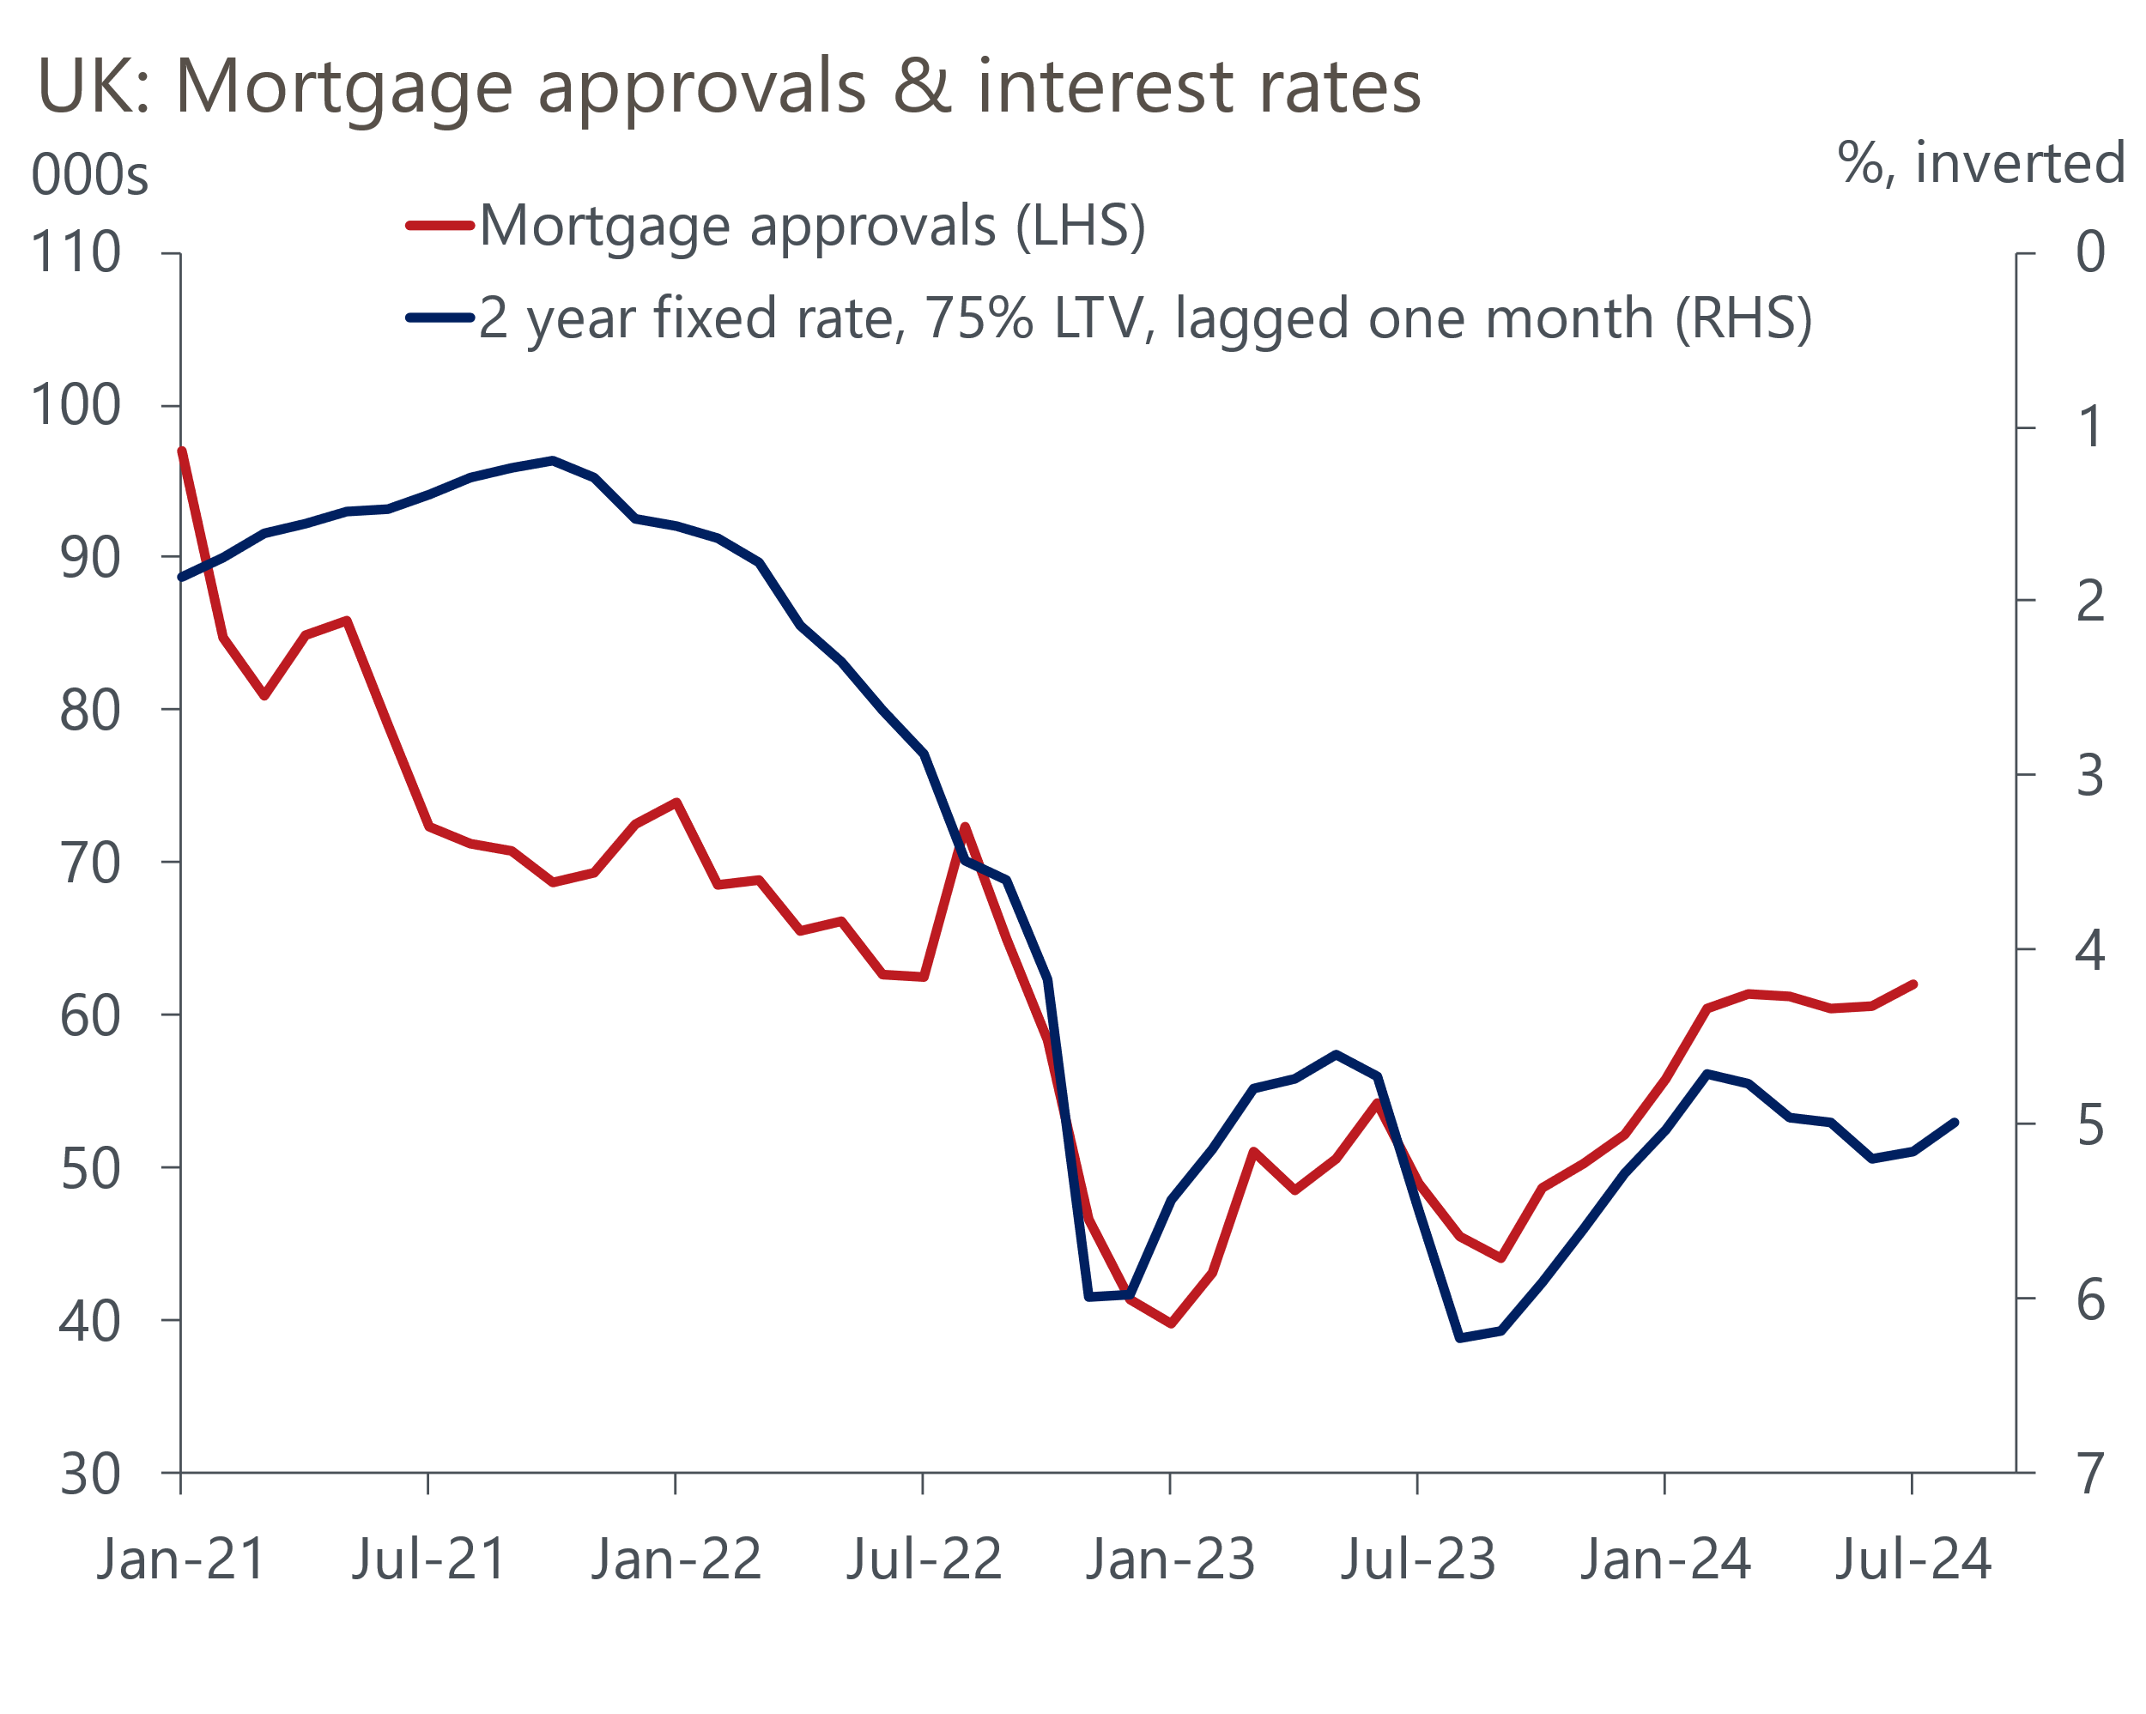
Source: Haver Analytics

August's data on quoted mortgage rates will be published next week, and timelier statistics from Moneyfacts suggest they're likely to show that average fixed-rate mortgage deals became cheaper again over the past month. This reflects markets taking a relatively dovish view of the Monetary Policy Committee's messaging. Between the June and August MPC meetings, markets moved to price an additional 25bps cut in H1 2025 (Chart 2). Swap rates have also fallen, with the two-year rate currently around 35bps below its mid-June level and the five-year rate 15bps lower. This suggests scope for mortgage rates to edge a little lower over the next few weeks.
Chart 2: We think the BoE will cut Bank Rate more slowly than markets anticipate
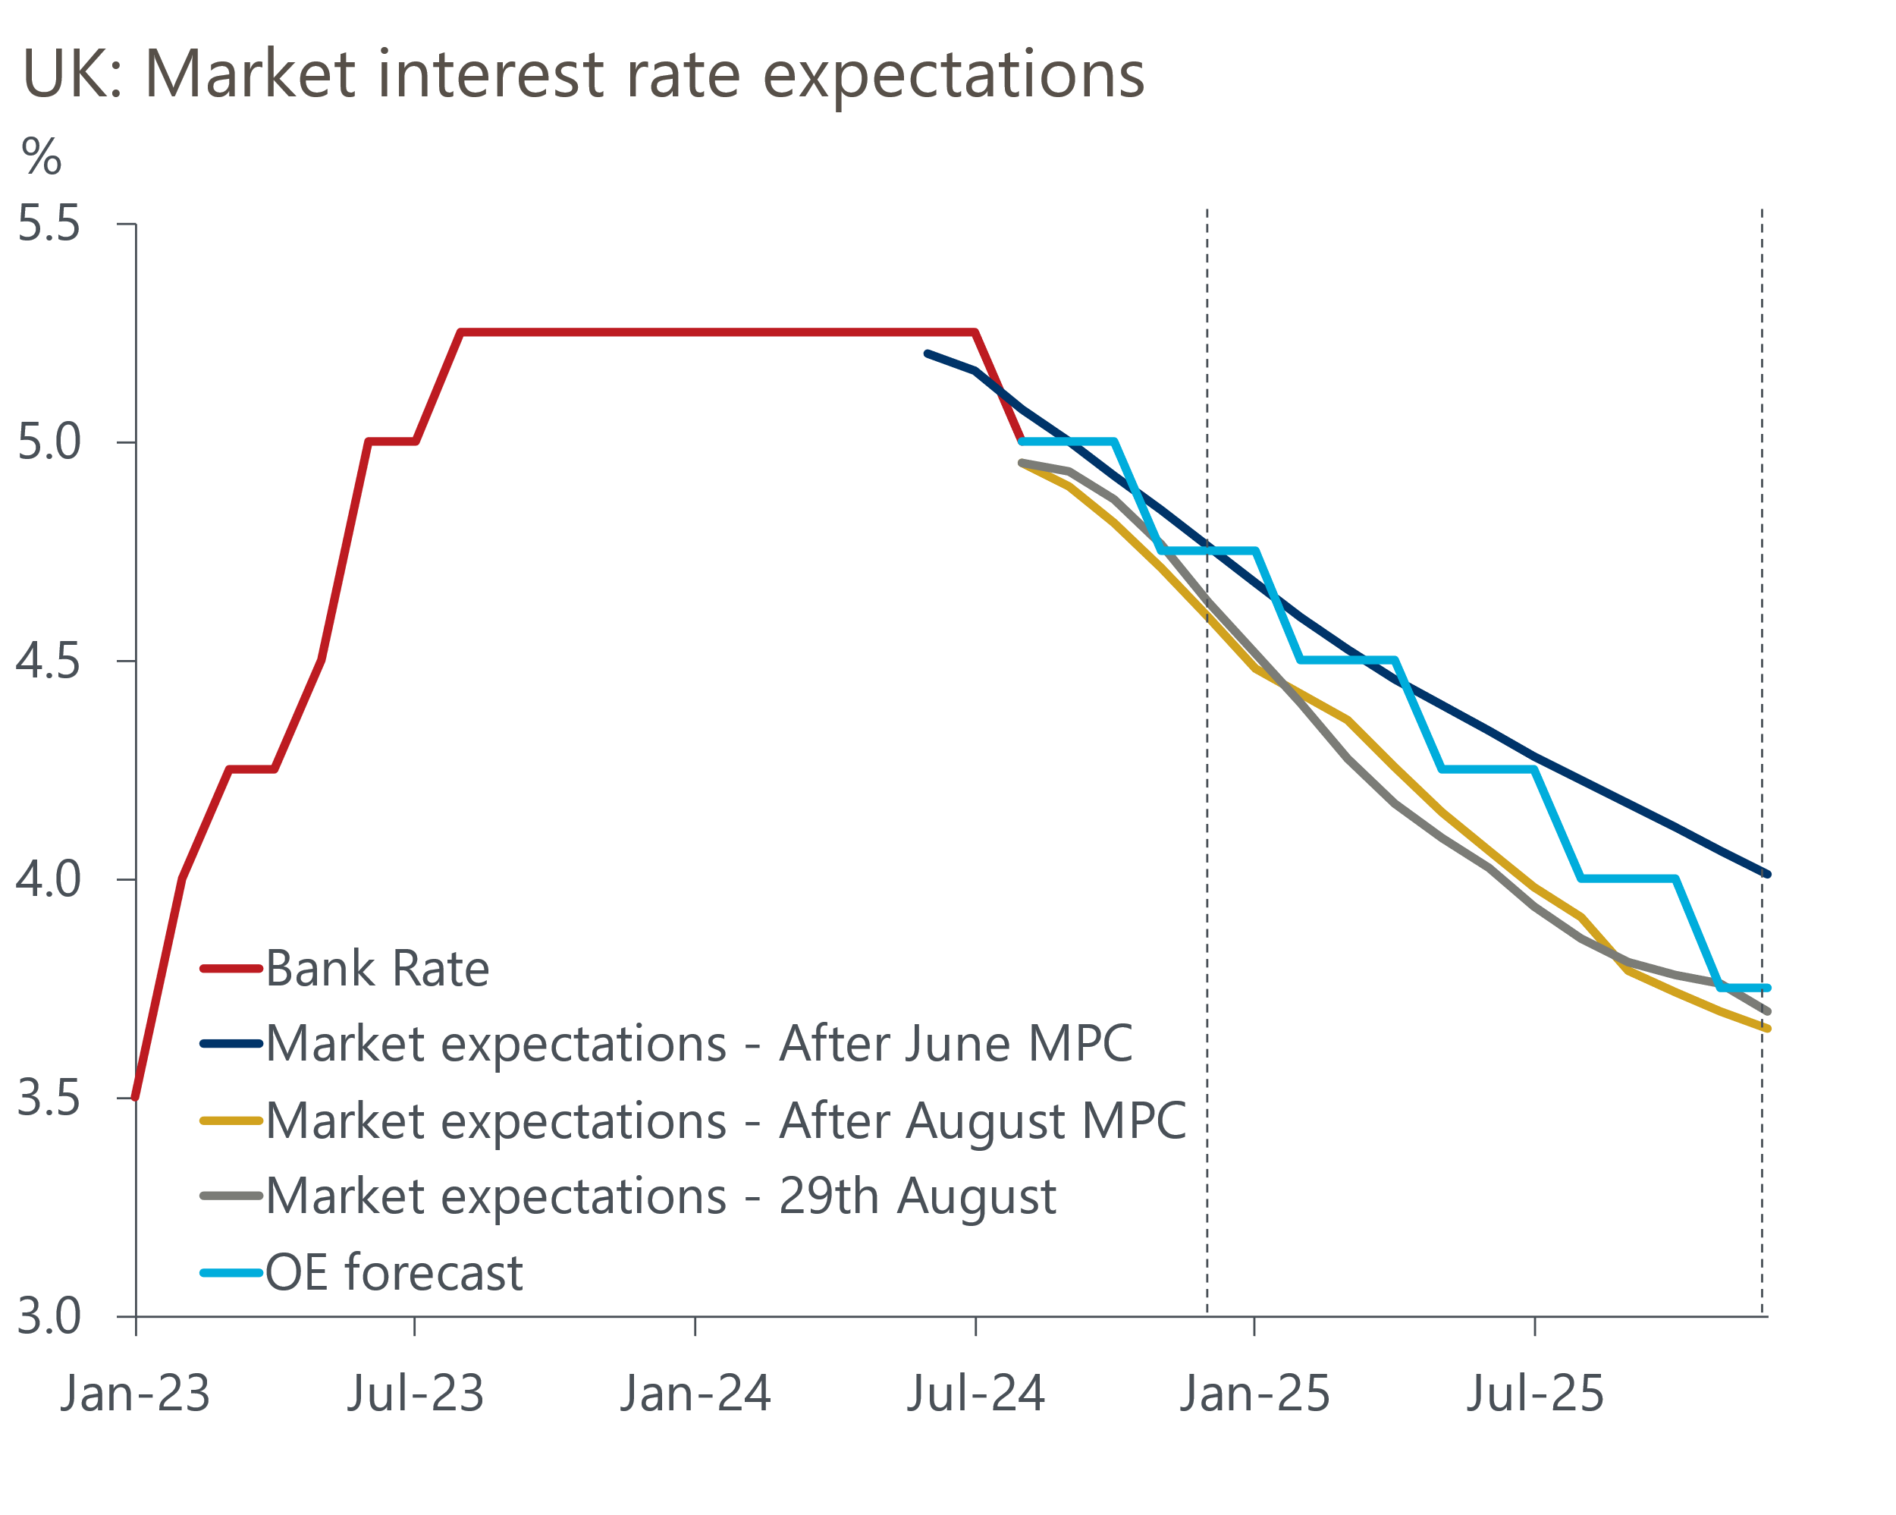
Sources: Oxford Economics, Haver Analytics
But we're sceptical that mortgage rates will fall by a more meaningful amount. Market pricing implies around 100bps worth of cuts by mid-2025, but we think a pace of 25bps per quarter – for a total of 75bps – is more realistic. In his speech at Jackson Hole last Friday, Governor Andrew Bailey reiterated the need for a gradualist approach to loosening policy given that the inflation battle has not yet been decisively won. And our forecasts suggest that inflation is more likely to surprise the MPC on the upside than the downside. So the chances of market pricing moving in an even more dovish direction, dragging down mortgage rates, look low at the current time. As a result, the recovery in mortgage approvals is likely to be slow.
A factor that could jolt the MPC out of its steady path of rate cuts would be much tighter fiscal policy. This week's speech by Prime Minister Keir Starmer continued to build the case for tax rises in the Budget on October 30, following on the back of the audit of public spending plans presented by the Chancellor last month. Starmer warned that the Budget will be "painful" and that "those with the broadest shoulders should bear the heavier burden". He name-checked Labour's manifesto pledge to crack down on the non-doms regime as being part of this. But the statement also appears consistent with reform of capital gains tax and changes to pension reliefs, both of which have been heavily rumoured in recent weeks.
One fear that we've had is that the Chancellor might find that cutting government investment – which is already planned to drop to very low levels – proves impossible to resist given current spending pressures and the government's self-imposed constraints on increasing taxation. But the Office for Budget Responsibility provided a clear warning of the consequences of this option in a discussion paper published this week. The paper found that a sustained 1% of GDP increase in public investment would raise the level of potential output by 0.5ppts after five years and 2.5ppts after 50 years, with the impact of capital spending cuts being symmetric. As this was a discussion paper, and the OBR is seeking feedback, the forecasts that accompany the Budget may not formally incorporate this work. But if the government did cut investment, we would expect the OBR to respond in the spirit of these findings, lowering its forecast for potential output and, all else equal, cutting its projection for tax revenues.
The OBR's findings also highlight one of the major failings of the fiscal rules that we've previously identified, namely that they excessively discourage capital spending because the bulk of the returns from public investment only emerge well beyond the five-year forecast horizon.

The week ahead
Next week's only major releases are the final S&P Global surveys for August. August's flash S&P Global survey reported stronger PMIs for both the manufacturing and services sectors, with the survey also reporting improving trends in new orders and hiring. There's no obvious bias to the revisions between the flash and final results, so we expect the outturns to broadly confirm this narrative.
Table 1: Week ahead calendar
Date | Events | Period | Measure | Unit | Previous | Forecast
Sep 2 | S&P Global/CIPS manufacturing | Aug | PMI | % bal | 52.5 | 52.5
Sep 4 | S&P Global/CIPS services | Aug | PMI | % bal | 53.3 | 53.3
Sep 4 | S&P Global/CIPS composite | Aug | PMI | % bal | 53.4 | 53.4
Sep 5 | S&P Global/CIPS construction | Aug | PMI | % bal | 55.3 | 55.5
Sep 6 | Halifax house prices | Aug | m/m | % | 0.8 | -0.5
Sep 6 | Halifax house prices | Aug | y/y | % | 2.3 | 3.6
Source: Oxford Economics

Key forecasts
Table 2: UK forecast overview
(Annual percentage changes unless specified)
 | 2022 | 2023 | 2024 | 2025 | 2026 | 2027
GDP | 4.3 | 0.1 | 1.1 | 1.8 | 1.8 | 1.7
Private consumption | 4.8 | 0.2 | 0.6 | 2.2 | 2.1 | 1.6
Fixed investment | 8.0 | 2.2 | 0.3 | 0.9 | 2.5 | 2.1
Government consumption | 2.3 | 0.5 | 2.7 | 2.8 | 1.6 | 1.5
Exports of goods and services | 9.0 | -0.5 | -0.7 | 2.4 | 2.2 | 1.7
Imports of goods and services | 14.6 | -1.5 | 0.8 | 3.1 | 2.8 | 1.9
Industrial Production | -3.5 | -0.4 | 0.0 | 0.9 | 1.5 | 1.2
Consumer prices | 9.1 | 7.3 | 2.6 | 2.5 | 2.2 | 2.2
Unemployment rate (%) | 3.9 | 4.0 | 4.3 | 4.3 | 4.1 | 3.9
Current a/c balance (% of GDP) | -3.1 | -3.3 | -3.5 | -3.3 | -3.3 | -3.3
Government balance (% of GDP) | 4.4 | 5.0 | 4.1 | 3.2 | 2.5 | 1.7
Cen. bank policy rate (%, EOP) | 3.50 | 5.25 | 4.75 | 3.75 | 2.75 | 2.00
10yr govt. bond yield (%, EOP) | 3.67 | 3.54 | 3.92 | 3.66 | 3.22 | 2.85
Exchange rate (US$ per £, EOP) | 1.20 | 1.27 | 1.28 | 1.28 | 1.30 | 1.32
Exchange rate (euro per £, EOP) | 1.13 | 1.15 | 1.18 | 1.17 | 1.17 | 1.16
Source: Oxford Economics
Table 3: Quarterly forecasts for the UK
 | 2024 |  |  |  | 2025
 | Q1 | Q2 | Q3 | Q4 | Q1 | Q2 | Q3 | Q4
GDP (% year) | 0.3 | 0.9 | 1.3 | 2.0 | 1.8 | 1.7 | 1.9 | 1.9
CPI inflation (% year) | 3.5 | 2.1 | 2.1 | 2.5 | 2.6 | 2.3 | 2.6 | 2.4
Bank Rate (%, EOP) | 5.25 | 5.25 | 5.00 | 4.75 | 4.50 | 4.25 | 4.00 | 3.75
10yr gilt yield (%, EOP) | 3.95 | 4.17 | 3.95 | 3.92 | 3.87 | 3.80 | 3.73 | 3.66
US$ per £ (EOP) | 1.26 | 1.26 | 1.27 | 1.28 | 1.28 | 1.28 | 1.28 | 1.28
Euro per £ (EOP) | 1.17 | 1.18 | 1.18 | 1.18 | 1.18 | 1.18 | 1.17 | 1.17
Source: Oxford Economics

Latest Country Economic Forecast:
August 21, 2024

Recent publications

Data Insights
Rate cuts should drive a gradual recovery in mortgage demand
Flash PMIs suggest economic growth will remain solid in Q3
Public finances continue to disappoint ahead of Budget reset
Noisy retail sales rebounded in July
Flat June completes another strong quarter for GDP

Research Briefings
Rate-cut cycle kicks off but it’s unlikely to be sequential
Reeves review lays the ground for October tax rises
MPC preview – Markets hold the key to timing of rate cut
Labour's fiscal inheritance and the Reeves Review
MPC prepares the ground for an August rate cut

Contacts

Oxford Economics' UK team
- Andrew Goodwin - Chief UK Economist - agoodwin@oxfordeconomics.com
- Edward Allenby - UK Economist - eallenby@oxfordeconomics.com

